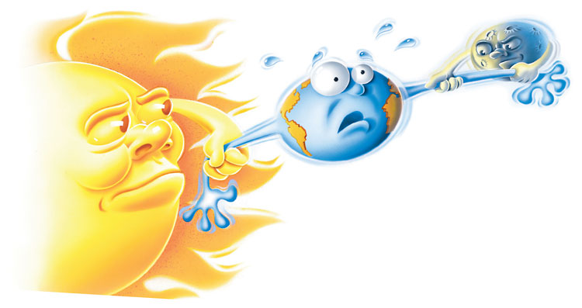 NOTES GRAPHIC ORGANIZER [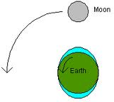](http://www.google.com/imgres?q=tides&um=1&hl=en&rlz=1W1ACGW_en&biw=1336&bih=609&tbm=isch&tbnid=KQY0RvARITrNaM:&imgrefurl=http://science.howstuffworks.com/tide-cause.htm&docid=q68z3p_g2lHcwM&imgurl=http://static.ddmcdn.com/gif/tides.gif&w=202&h=180&ei=V7M-T5bmBMeWtwfan5TgBQ&zoom=1)

**TIDES**

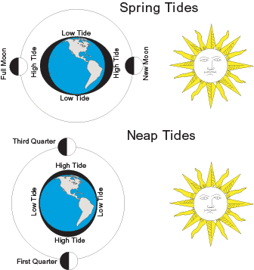 

|  |  |
| --- | --- |
| 1. Tides: Definition | 1. What causes tides? |
|  |  |
| 1. Does the Sun or the Moon have greater gravitational influence on Earth’s tides and why? | 1. How often tides occur and the difference in tidal levels depends on… |
|  |  |
| 1. What are Spring tides? | 1. What are Neap tides? |
|  |  |