Name______________________________________ Period ___________

**Seasons, Tides, and Moon Phases Review**

**Rotation and Revolution**

1. What is Earth’s axis?
2. What is the difference between Earth’s rotation and revolution?
3. What causes day and night?
4. What causes the seasons?
5. Compare and Contrast Solstices to Equinox.
6. Label the season and earth’s revolution in the diagram. Draw an arrow representing earth rotation and label that as well.

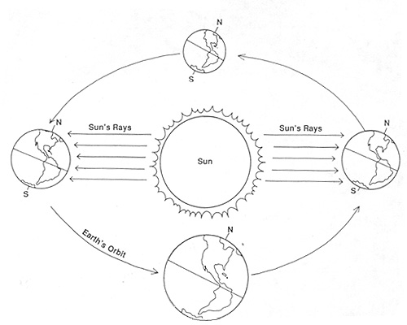

**Lunar Cycle**

1. What is the role of the Sun in the occurrence of the lunar cycle?
2. How long is one lunar cycle/moon’s revolution around earth?
3. Draw the phases of the moon and label them. Also label where the terms waxing and waning occur. Next, draw the arrow of the direction that the phases occur, starting with a new moon. Identify where you will see a solar eclipse, lunar eclipse, spring tides and neap tides.

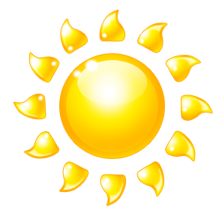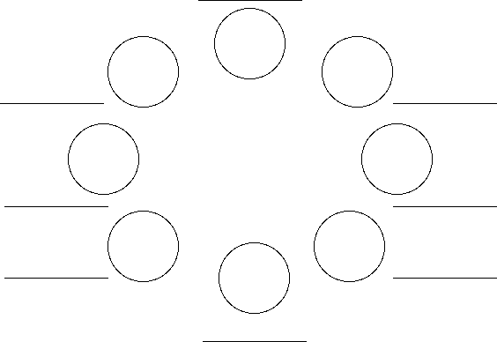

1. What do the terms waxing and waning mean?
2. What do the terms gibbous and crescent mean?
3. What does the term a quarter moon mean?
4. What is a meant by the terms a full moon and a new moon?
5. Describe the difference between Solar and Lunar Eclipse.

**Tides**

1. What affect does the gravitational pull of the moon and the sun have on Earth?
2. What causes tides to occur on Earth?
3. What is a high tide? A low tide?
4. What is a neap tide? A spring tide?
5. What moon phases go with neap tide? What moon phases go with spring tide?