**Adaptation and Natural Selection: Quiz**



**A. Multiple Choice: Write down the letter the best answers the question/statement.**

**­­___1. What is the definition of species?**

a) a trait that helps an organism survive and reproduce

b) a group of similar organisms that can mate and produce fertile offspring.

c) a well tested concept that explains a wide range of observations

d) a group of animals with similar appearance

**___2. An adaptation is a trait that helps an organism…**

a) fight better b) overproduce variations c) survive and reproduce d) larger and stronger

**___3. As a result of global warming, what changes could we *infer* might eventually be seen in polar bears?**

a) they will develop thicker, warmer coats

b) they will develop thinner and darker fur

c) they will lose their ability to swim

d) they will become herbivores

**___5. The process of organisms fighting for mates, food and living space is called:**

a) adaptation b) evolution c) competition d) all of the above

**___6. Natural selection is based on...** a) overproduction b) variation c) competition d) all of the above

**Application: Based on your knowledge of adaptations and natural selection. Write down the letter the best answers the question/statement.**

**7. A scorpion is an effective predator in its niche. What set of adaptations would help a scorpion *catch and overcome* its prey?**

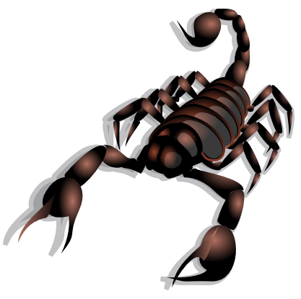

a. claws and tail with a stinger

b. exoskeleton and tail with a stinger

c. powerful legs, tail with a stinger, and exoskeleton

d. claws, powerful legs, and exoskeleton

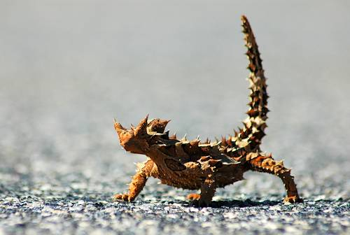

1. **Examine this lizard. Based on the features of this lizard what would best describe the animal’s habitat?** 
   1. moist, damp ecosystem; often eaten by predators
   2. dry, desert-like ecosystem; often eaten by predators
   3. moist, damp ecosystem; not bothered by predators
   4. dry, desert-like ecosystem; not bothered by predators
2. The walking catfish is a type of fish that inhabits many waterways in Florida. This catfish has special organs that allow it to breathe oxygen from the atmosphere, as well as spikes on its fins that allow it to “walk” awkwardly across dry land. Walking catfish have been seen walking across roads, on grass, and even on people’s driveways.

**What kind of environmental change most likely led to these unique adaptations in the walking catfish?**

1. As the population of predators in their environment increased, catfish with the breathing and walking traits were able to escape to a different waterway.
2. As the catfish food supply diminished, catfish with the breathing and walking traits moved on to land to hunt for land animals to eat
3. As water temperatures increased, catfish with the breathing and walking traits left their environment to find relief in shaded areas
4. As water in their environment began to dry up, catfish with the breathing and walking traits left their environment to find nearby waterways with more water.
5. **Genetic variation can aid in the survival of species when the environment changes. Which of the following is the best example of an organism with a genetic variation that could improve survival chances over time?** 
   * 1. An ant that is resistant to pesticide
     2. A wasp that is infected with parasites
     3. A cactus that has no spines
     4. A mouse that has learned to avoid mousetraps